**Happy Haven Day Care**

**Network Proposal**



Consultant: Christian Hill

**Macro Computer Consultants**

**Overview**

* Cable
  + CAT5e Ethernet Patch Cord, 24 AWG UTP cable
    - 25 bulk pack
    - 1ft
    - $12.96 or 25.92 for two
  + CAT5e Ethernet Patch Cord, 24 AWG UTP cable
    - 25 bulk pack
    - 5ft
    - $24.24
  + CAT5e Ethernet Patch Cord, 24 AWG UTP cable
    - 25 bulk pack
    - 10ft
    - $42.00
  + CAT5e Ethernet Patch Cord, 24 AWG UTP Plenum cable
    - 25 bulk pack
    - 50ft
    - $145.00
  + B-Line J-Hook, 30lb. max load capacity
    - $99.00
  + Nylon 6/6 cable Tie kit, assorted colors, 100 pieces
    - $33.50 or two for $67.00
* Switch
  + Cisco Small Business 200 series SLM2048T-NA
    - 48 ports
    - Supports up 1000MBPs
    - Supports power over Ethernet (PoE)
    - $428.98
* Server
  + HPE ProLiant ML110 Gen9 tower server
    - Automates the most essential server life cycle management tasks
    - Deploy, update, monitor, and maintain with ease
    - 10 TB SAS/SATA Hard Disk Drive
    - 8 GBs of RAM
    - $872.99
* Server Rack
  + Tripp Lite 42U Standard-Depth server rack enclosure cabinet
    - Maximum load capacity of 3000 lbs.
    - Includes doors and side panels
    - Unit Dimensions: 78.5 x 23.63 x 43 inches.
    - $1079.00
  + TREND net 48-Port CAT5/5e 20U Rack-Mount Patch Panel
    - Backward compatible with CAT 3/4/5 cabling
    - product dimensions: 19.8 x 4.1 x 2.3 inches
    - $49.99
* Server uninterruptible power supply
  + APC BR1500G Backups Pro 1500 VA 10 outlets UPS
    - Guaranteed protection and battery backup power for your valuable electronics, ensuring they remain safe from dangerous power disturbances
    - Guaranteed protection from surges and spikes caused by storms, lightning, circuit overloads, power cycling, etc.
    - $167.32
* Surge protector
  + Tripp Lite Protect it! TLP1008TEL
    - 10 outlets with 2395 joule surge suppressor
    - Lifetime Warranty and $150,000 Ultimate Lifetime Insurance for connected devices.
    - $25.00 or three for $75.00
* Monitors
  + HP 2V2311 23” widescreen LED LCD Monitor
    - VGA
    - Stand included
    - $64.99 each or $1,949.70 for 30 stations
  + Generic VGA Cable
    - $2.49 each or $74.70 for 30 stations

**Class Rooms**

* Workstations
  + HP ProDesk 400 G3 Small Form Factor Desktop PC
    - Windows 10 pro 64
    - 4GB RAM
    - 500GB Hard Drive
    - Keyboard
    - Mouse
    - Warranty
    - $451.94 each or $2,711.64 for 6 workstations

**Computer Lab**

* Work Stations
  + HP ProDesk 400 G3 Small Form Factor Desktop PC
    - Windows 10 pro 64
    - 4GB RAM
    - 500GB Hard Drive
    - DVD ROM
    - Keyboard
    - Mouse
    - $581.15 each or $11,623.00 for 20 stations
* Printer
  + HP LaserJet Pro M501dn Monochrome Laser Printer
    - $399.99
  + HP 87A Black Original LaserJet toner cartridge CF287A
    - Reliable and standard
    - Lasts up to 9,000 pages
    - $236.99 each

**Administration Offices**

* Desktop
  + HP ProDesk 400 G3 Small Form Factor Desktop PC
    - Windows 10 pro 64
    - intel® Core™ i3-6300
    - 4GB RAM
    - 1TB Hard Drive
    - DVD drive
    - Keyboard
    - Mouse
    - $1,250.80 for two
* Printer
  + HP Color LaserJet Pro MFP M277 dw
    - Print, copy, scan, and fax
    - Print speed letter: 19 ppm (black and color)
    - Scan to email; Auto duplex printing; 2 paper trays (standard)
    - $549.95
  + HP 201X High Yield original laser jet toner cartridges
    - Lasts 2,300 pages per cartridge
    - $109.99 or $329.97 for all three colors
  + HP 201X High Yield original laser jet toner cartridge
    - Lasts 2,800 pages per cartridge
    - $98.99

**Security**

* Cameras
  + Zmodo 4 Channel HD Security Camera PoE System
    - Simplified Power over Ethernet means the IP cameras connect to the NVR with a single cable that transmits both data and power, allowing for an easy installation and setup
    - 4 HDMI High Resolution NVR + (4) 720p HD cameras
    - Record up to 100 days for 4 cameras
    - Control and view your security kits from anywhere on your smart phone using the free Zmodo app
    - $239.99

**Software**

* Microsoft Office Products 2016
  + Microsoft Office Home and Business 2016
    - 1 PC (1 License)
    - $105.99 or $2649.75 for 25 computers
* Windows server 2008
  + Windows Essential Business Server 2008
    - Combines several Microsoft server products and technologies into a single, integrated solution
    - Provides tools to create application add-ins and security adapter add-ins to manage additional applications and security issues
    - $0.00 (free as of 2010)
* Security
  + McAfee Complete EndPoint Protection Business
    - an all-in-one solution that provides endpoint security for key devices in your enterprise
    - anti-malware, firewall, device control, and email and web security
    - $129.99
  + McAfee Complete EndPoint Protection Business Licenses
    - 25-50 users and 1 Year Gold Business Support
    - $23.56

**Labor**

* Installation
  + Hourly rate
    - 8 hours * $90 hourly rate = $720 a day
    - After 5-day completion: $3,600.00

**Budget**

* 1 ft CAT5e Ethernet Patch Cord, 24 AWG UTP cable two packs- $25.92
* 5 ft CAT5e Ethernet Patch Cord, 24 AWG UTP cable two packs $24.24
* 10 ft CAT5e Ethernet Patch Cord, 24 AWG UTP cable two packs $42.00
* 50 ft CAT5e Ethernet Patch Cord, 24 AWG UTP cable two packs $145.00
* B-Line J-Hook $99.00
* 2 Nylon 6/6 cable Tie kit, assorted colors, 100 pieces $67.00
* Switch: Cisco Small Business 200 series SLM2048T-NA $428.98
* Server: HPE ProLiant ML110 Gen9 tower server $872.99
* Server Rack: Tripp Lite 42U Standard-Depth enclosure cabinet $1079.00
* TREND net 48-Port CAT5/5e 20U Rack-Mount Patch Panel $49.99
* Server uninterruptible power supply: APC BR1500G Backups Pro 1500 VA 10 outlets UPS $167.32
* Surge Protector: Tripp Lite Protect it! TLP1008TEL $75.00
* 30 Monitors: HP 2V2311 23” widescreen LED LCD Monitor $1949.70
* 30 Generic VGA cables $74.70
* 6 Employee Workstations: HP ProDesk 400 G3 Small Form Factor Desktop PC $2,711.64
* 20 Computer Lab Workstations: HP ProDesk 400 G3 Small Form Factor Desktop PC $11,623.00
* Computer lab printer: HP LaserJet Pro M501dn Monochrome Laser Printer $399.99
  + Toner: HP 87A Black Original LaserJet toner cartridge CF287A $236.99
* 2 Admin Desktop: HP ProDesk 400 G3 Small Form Factor Desktop PC $1250.80
* Admin office printer/scanner: HP Color LaserJet Pro MFP M277 dw $549.95
  + Color Toner: HP 201X High Yield original laser jet toner cartridges $329.97
  + Black Toner: HP 201X High Yield original laser jet toner cartridge $98.99
* Camera System: 4 cameras for the building: Zmodo 4 Channel HD Security Camera PoE System $239.99
* Microsoft Office Home and Business 2016: for 25 computers $2,649.75
* Windows Server 2008: software and licenses $0.00
* Internet Security: McAfee security including 50 licenses $153.55
* Labor: My work for 5 days $3,600.00

**TOTAL: $28,945.46**

**Legend**

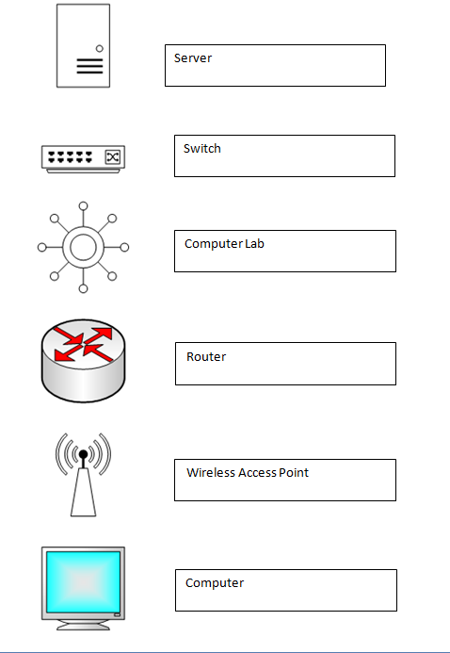

**Notes**

_____________________________________________________________________________________________________________________________________________________________________________________________________________________________________________________________________________________________________________________________________________________________________________________________________________________________________________________________

_____________________________________________________________________________________________________________________________________________________________________________________________________________________________________________________________________________________________________________________________________________________________________________________________________________________________________________________________

_____________________________________________________________________________________________________________________________________________________________________________________________________________________________________________________________________________________________________________________________________________________________________________________________________________________________________________________________

_____________________________________________________________________________________________________________________________________________________________________________________________________________________________________________________________________________________________________________________________________________________________________________________________________________________________________________________________

_____________________________________________________________________________________________________________________________________________________________________________________________________________________________________________________________________________________________________________________________________________________________________________________________________________________________________________________________

_____________________________________________________________________________________________________________________________________________________________________________________________________________________________________________________________________________________________________________________________________________________________________________________________________________________________________________________________